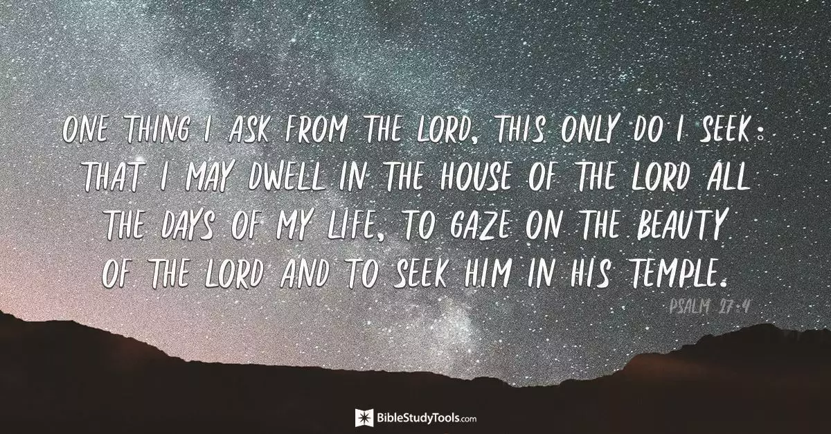

Plan for Quiet Day – Focus on Psalm 27
9:30 Introduction, Session 1: Song, Liturgy, Reflection on V1-6 in words and music
Quiet
(10:50 Coffee & Share)
11:00 am Session 2: Liturgy and prayer activity, Reflection on v7-14 in words and music
Quiet
(12:10 Coffee & Share)
12:20 Final Prayers & Blessing

Session 1
Wait for the lord,
whose day is near

Wait for the lord,
keep watch,
take heart

Opening words
The Lord is my light and my salvation;
whom shall I fear?
The Lord is the stronghold of my life;
of whom shall I be afraid?

Let us pray
Almighty God, you have created the heavens and the earth and made us in your own image: teach us to discern your hand in all your works and your likeness in all your children; through Jesus Christ your Son our Lord, who with you and the Holy Spirit reigns supreme over all things, now and for ever.
Amen

Confession
Lord Jesus, we are sorry when we have not placed our trust in you
when you have not been our light and our salvation
when you have not been our stronghold
when our trust has been solely in ourselves or others
when we have been governed by fear not love

(Absolution)
May the Father of all mercies cleanse us from our sins,
and restore us in his image to the praise and glory of his name, through Jesus Christ our Lord.
Amen.

Prayer of confidence and hope amidst adversity

When evildoers assail me
to devour my flesh—
my adversaries and foes—
they shall stumble and fall.
Though an army encamp against me,
my heart shall not fear;
though war rise up against me,
yet I will be confident.

Prayer of seeking:

One thing I asked of the Lord,
that will I seek after:
to live in the house of the Lord
all the days of my life,
to behold the beauty of the Lord,
and to inquire in his temple.
For he will hide me in his shelter
in the day of trouble;
he will conceal me under the cover of his tent;
he will set me high on a rock.
Now my head is lifted up above my enemies all around me,
and I will offer in his tent sacrifices with shouts of joy;
I will sing and make melody to the Lord.

Psalm 72:1-6
The Lord is my light and my salvation; whom shall I fear?
The Lord is the stronghold of my life; of whom shall I be afraid?
When evildoers assail me to devour my flesh—
my adversaries and foes— they shall stumble and fall.
Though an army encamp against me, my heart shall not fear;
though war rise up against me, yet I will be confident.
One thing I asked of the Lord, that will I seek after:
to live in the house of the Lord all the days of my life,
to behold the beauty of the Lord, and to inquire in his temple.
For he will hide me in his shelter in the day of trouble;
he will conceal me under the cover of his tent; he will set me high on a rock.
Now my head is lifted up above my enemies all around me,
and I will offer in his tent sacrifices with shouts of joy;
I will sing and make melody to the Lord.

What word, phrase or idea strikes you from this passage – you might like to share it on chat.

We continue to reflect on this passage through music

Moving into Quiet:
Take this time to continue to reflect on this passage independently
You might want to sit somewhere comfortable, draw or paint or go for a walk.
What is God saying to you through the word phrase or idea that strikes you?
What difference will this make to your life?
Speak to him about it. Let him lead you.

Session 2
Opening words
Hear, O Lord, when I cry aloud,
be gracious to me and answer me!
‘Come,’ my heart says, ‘seek his face!’
Your face, Lord, do I seek.

Prayer of confidence and hope amidst adversity
Do not hide your face from me.
Do not turn your servant away in anger,
you who have been my help.
Do not cast me off, do not forsake me,
O God of my salvation!
If my father and mother forsake me,
the Lord will take me up.
Teach me your way, O Lord,
and lead me on a level path
because of my enemies.
Do not give me up to the will of my adversaries,
for false witnesses have risen against me,
and they are breathing out violence.
Silence to hand over our adversities and struggles to God.
Prayer of seeking
I believe that I shall see the goodness of the Lord
in the land of the living.
Wait for the Lord;
be strong, and let your heart take courage;
wait for the Lord!

Psalm 27:7-14

Hear, O Lord, when I cry aloud, be gracious to me and answer me!
‘Come,’ my heart says, ‘seek his face!’
Your face, Lord, do I seek. Do not hide your face from me.
Do not turn your servant away in anger, you who have been my help.
Do not cast me off, do not forsake me, O God of my salvation!
If my father and mother forsake me, the Lord will take me up.
Teach me your way, O Lord, and lead me on a level path
because of my enemies.
Do not give me up to the will of my adversaries, for false witnesses have risen against me, and they are breathing out violence.
I believe that I shall see the goodness of the Lord in the land of the living.
Wait for the Lord; be strong, and let your heart take courage; wait for the Lord!

What word, phrase or idea strikes you from this passage – you might like to share it on chat.

We continue to reflect on this passage through music

Moving into Quiet:
Take this time to continue to reflect on this passage independently
You might want to sit somewhere comfortable, draw or paint or go for a walk.
What is God saying to you through the word phrase or idea that strikes you?
What difference will this make to your life?
Speak to him about it. Let him lead you.

Session 3
Opening words
The Lord is my light and my salvation;
whom shall I fear?
The Lord is the stronghold of my life;
of whom shall I be afraid?

Prayer of seeking
I believe that I shall see the goodness of the Lord
in the land of the living.
Wait for the Lord;
be strong, and let your heart take courage;
wait for the Lord!

Prayer of Response to today

Concluding with the Lords prayer

Our Father in heaven,
hallowed be your name,
your kingdom come,
your will be done,
on earth as in heaven.
Give us today our daily bread.
Forgive us our sins
as we forgive those who sin against us.
Lead us not into temptation
but deliver us from evil.
For the kingdom, the power,
and the glory are yours
now and for ever.
Amen.

Blessing

